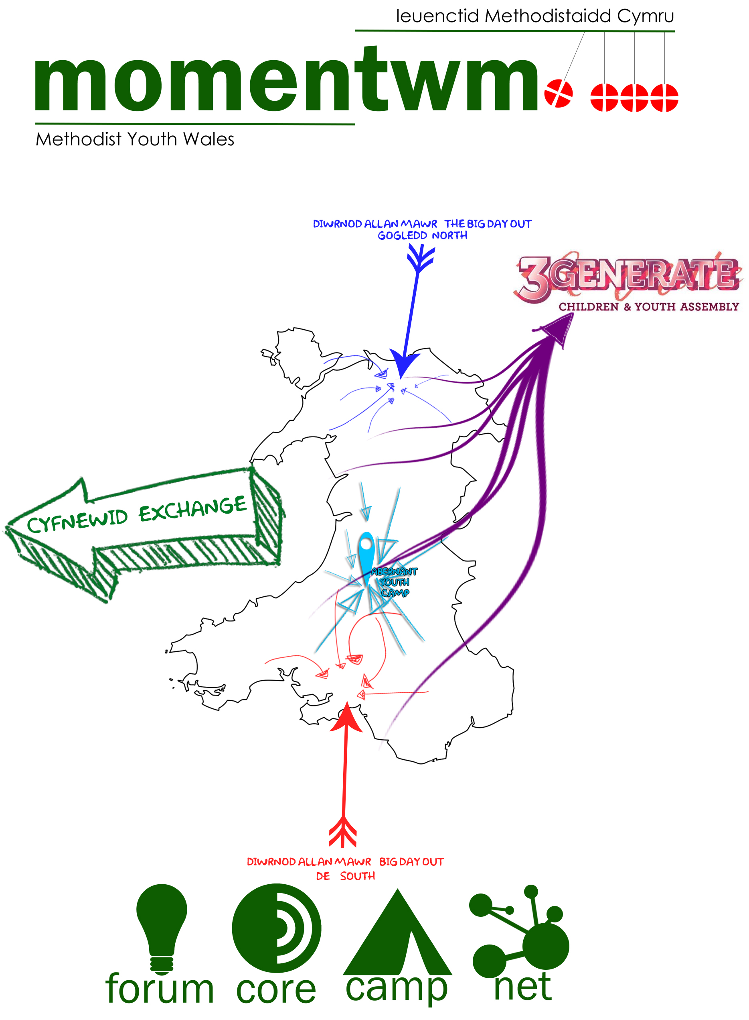

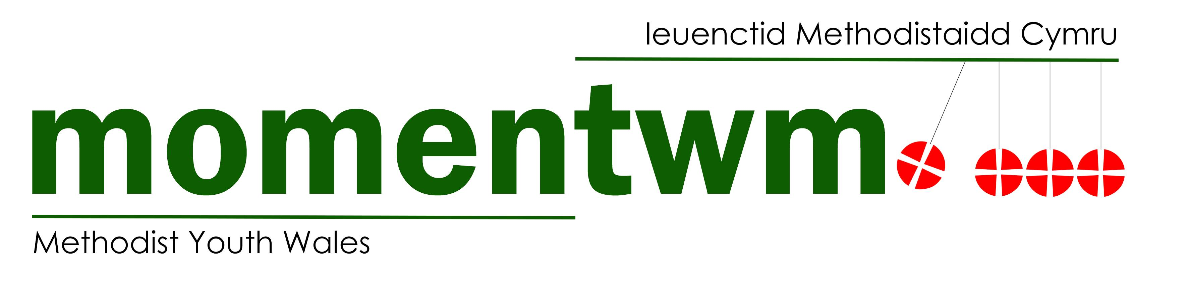

Aims/Objectives
- To work with young people between the ages of 10 and 26 in various settings and other ages where appropriate
- To organise events to bring the Methodist young people of Wales together.
- To promote faith development and discipleship in the young people we engage with
- To create Christian Communities, virtual and physical, for the young people of Wales
- To encourage young people to participate in their churches and communities.
- To challenge and guide young leaders
- To work with churches with connections to universities and colleges and support student work
- To act as a signposting service and a central hub.
- To keep everyone informed about Youth Work in Wales, in the Connexion and beyond.
- To direct youth workers to training, support and forming communities of practice.
- To promote equality, diversity and inclusion.

Strands
Momentwm Core
- Group drawn from across Wales who organise, plan, deliver and monitor the strands.

Momentwm Forum
- Forum happens whenever and wherever Momentwm gather
- We make space to hear the voice of young people
- We bring to the young people issues affecting the Church
- We bring from Forum issues concerning young people to the church
- These conversations and feedback are brought to the wider church through the Core group

Momentwm Exchange
- Live on a bigger map and experience the diversity of the worldwide church.
- Be challenged by the high expectations placed on them and by the new experiences they will encounter.
- Meet and work with new people from a range of different backgrounds.
- Use their gifts by developing previous skills or learning new ones.
- Potential to learn about themselves and grow in confidence and faith.

Momentwm Big Day Out (or BIG DAY IN in case of Pandemic)
- Engage with the same themes as 3 Generate (we follow their lead).
- Meet other YP from around the region (Big Day Out runs in both the North and the South)
- Includes worship, workshops and fun activities.
- Being be part of something bigger.
- Develop the skills of our young adult leaders.

Momentwm Camp
- A longer gathering to make deeper relationships.
- Develop teamwork skills with the activities on offer (raft building, climbing and abseiling, archery and wide games).
- An opportunity to engage with the Connexional Youth President (virtually or in person).
- Times of extended discussion, worship and workshops.
- Develop the skills of our young adult leaders.
- An in-depth opportunity to grow in faith.

Momentwm Local
- Supporting local youth work with Wales based training.
- Signposting to resources or other training providers.

Momentwm Net
- Our online presence through Facebook, Twitter, Instagram and YouTube.
- Connecting youth workers and youth groups to resources through our Blog
- Online meet ups like the BIG DAY IN and Momentwm Meet-ups
