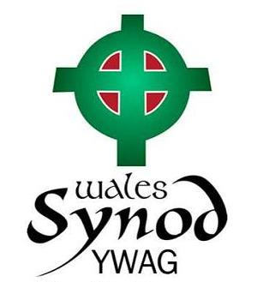
Participant
Name

Home address

Date of Birth

e-mail address

Mobile Number
Details of any regular medication
Details of any medical problems
(e.g. allergies, dietary needs, asthma, epilepsy, diabetes)
Church/Circuit

Youth Forum 2014
Participation Consent form
13th September 2014. Theatr Hafren, Llanidloes Road, Newtown, s SY16 4HU
Parent/Carer/Responsible Adult
Name

Home address

Home Phone Number

Mobile or other emergency numbers

e-mail address

The Consent
Tick
I give permission for the participant named above to take part in the activities of the Youth Forum.
I understand that while involved he/she will be under the control and care of the group leader and/or other adults approved by the church leadership and that, while the staff in charge of the group will take all reasonable care of the young people, they cannot necessarily be held responsible for any loss, damage or injury suffered by the participant during, or as a result of, the activities of the Youth Forum.
Using your personal information
I understand that the data I have given will be used for the purposes of The Youth Forum and the administration of the Methodist Church.
Photos may be taken for the purposes of The Youth Forum and other Methodist Church purposes including future publicity materials.
In the event of an emergency and/or if I am not contactable, I am willing for my child to receive necessary medical treatment which may include first aid, hospital or dental work including an anaesthetic

Signatures
Signature |  |  | Signature
Participant |  |  | Parent/Carer
Date |  |  | Date

