Before Christmas I was working with the drama class in St Christopher’s school. We worked on a nativity project which was performed at St Giles and went really well. I worked with them for a term and all the hard work all the students put in really did pay off.
Another thing I got to be part of was the schools Christmas carol service at St Giles where story cubes that had been made in schools were received. So much hard work was put into creating these story cubes and it was lovely to see how much thought and effort had been put into every single one.

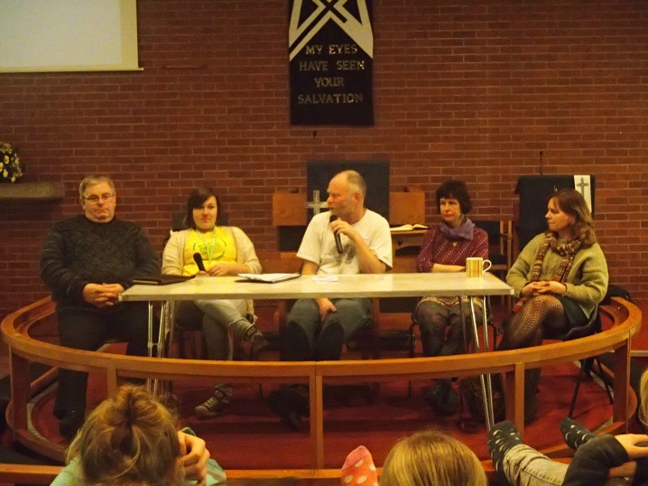
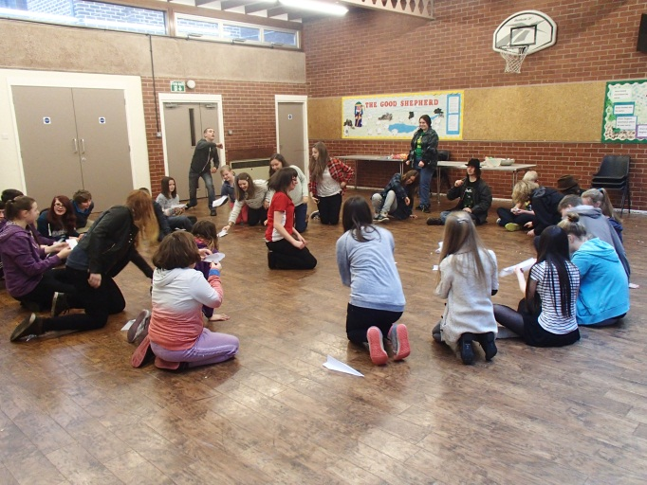
In February we had ‘The Big Sleepover’ event at Wrexham Methodist church, which around 30 young people attended from across North Wales. The Big Sleepover started in 2012 and all three years have been successful events. Three sleepovers happen across Wales and young people are invited through the churches to attend their nearest one. Topics discussed at 3Generate, the Methodist youth assembly, that happens every year in November, are discussed and themes from the weekend are also used. The weekend was full of fun activity sessions, big questions and very little sleep.
The Methodist church this year is sponsoring a male and a female team from Nicaragua to attend the Street Child World Cup, which started the 28th March for ten days. At the sleepover we were lucky enough to have Roxanne, who visited Nicaragua with the Methodist church in November, attend the Big Sleepover to talk about her time there and how we can help.

I am over halfway in my OPP year and already it has been an amazing experience. I have great plans for next term, during the summer and hopefully these will be successful!

